LED Outdoor Wash Light

60X10W RGBW 4in1 LED

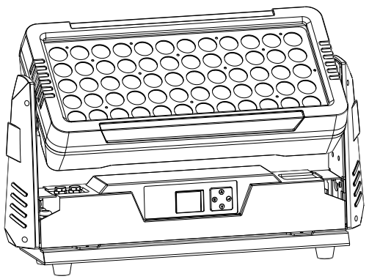

USER MANUAL

Thank you very much for choosing our product. For safety purpose, please read this manual carefully before your operation. This manual included installation and using information. Please install and operate it according to this manual.

Part 1 PRDUCT
  - Product introduction
This product is designed for indoor/outdoor use. Suitable applications include wash or effect lighting for architectural, stage or nightclub applications. This product can also be installed for use in signage and advertising using the dynamic functions available with DMX512 control. Direct input of DMX512 signal allows the units to be controlled from any DMX512 controller. This product can be operated as a single unit or in multiple units for large applications.

1.2 Technical Specifications
Voltage: AC100-240V, 50/60Hz
Power: 650W
Light Source: 60X10W RGBW 4in1 LED
IP Rating: IP65
Lifespan: around 100,000 hours
Housing: Die-casting aluminum, powder-coated finish
Control: DMX 512, 4/6/9CH
Control Mode: DMX, Auto, Master/Slave mode
Dimmer: 0-100%
Strobe: 0-20Hz
Beam angle: 25º
N.W: 16KG

1.3 Safety Warning
IMPORTANT:
ALWAYS READ THE USER MANUAL BEFORE OPERATION. PLEASE CONFIRM THAT THE POWER SUPPLY STATED ON THE PRODUCT IS THE SAME AS THE MAINS POWER SUPPLY IN YOUR AREA.
● This product must be installed by a qualified professional.
● Always operate the equipment as described in the user manual.
● A minimum distance of 0.5m must be maintained between the equipment and combustible surface.
● The product must always be placed in a well ventilated area.
● Always make sure that the equipment is installed securely.
● DO NOT stand close to the equipment and stare directly into the LED light source.
● Always disconnect the power supply before attempting and maintenance.
● Always make sure that the supporting structure is solid and can support the combined weight of the products.
● The earth wire must always be connected to the ground.
● Do not touch the power cables if your hands are wet.

ATTENTION:
● This product left the place of manufacture in perfect condition. In order to maintain this condition and for safe operation, the user must always follow the instructions and safety warnings described in this user manual.
● Avoid shaking or strong impacts to any part of the equipment.
● Make sure that all parts of the equipment are kept clean and free of dust.
● Always make sure that the power connections are connected correct and secure.
● If there is any malfunction of the equipment, contact your distributor immediately.
● When transferring the product, it is advisable to use the original packaging in which the product left the factory.
● Shields, lenses or ultraviolet screens shall be changed if they have become damaged to such an extent that their effectiveness is impaired.
● The lamp (LED) shall be changed if it has become damaged or thermally deformed.

PART 2 INSTALLATION
2.1 Mounting:
2.1-1 Hanging
The product can be mounted in a hanging position using the supporting bracket. The bracket should be secured to the mounting truss or structure using a standard mounting clamp. Please note that when hanging the unit a safety cable should also be used
.
2.1-2 Upright
The product can be mounted in an upright or sitting position using the supporting brackets.
NOTE:
The product can be mounted at any angle and in any position. It is possible to further adjust the angle of the product using the two adjustment knobs located on the side of the fixture.

2.2 DMX Channel instruction
4CH | 6CH | 9CH | Function | Value | Instruction
 | 1 | 1 | Dimmer | 0-255 | Dimmer, from dark to bright
 | 2 | 2 | Strobe | 0-3 | No function
 |  |  |  | 4-255 | Strobe from slow to fast
1 | 3 | 3 | Red Dimming | 0-255 | Red Dimming, from dark to bright
2 | 4 | 4 | Green Dimming | 0-255 | Green Dimming, from dark to bright
3 | 5 | 5 | Blue Dimming | 0-255 | Blue Dimming, from dark to bright
4 | 6 | 6 | White Dimming | 0-255 | White Dimming, from dark to bright
 |  | 7 | Color Selection | 0-31 | No function
 |  |  |  | 32-63 | Red
 |  |  |  | 64-95 | Green
 |  |  |  | 96-127 | Blue
 |  |  |  | 128-159 | White
 |  |  |  | 160-191 | Red+Green
 |  |  |  | 192-223 | Red+Blue
 |  |  |  | 224-255 | Green+Blue
 |  | 8 | Macro Funciton | 0-50 | No function
 |  |  |  | 101-150 | Color Change
 |  |  |  | 151-200 | Color Gradual
 |  |  |  | 201-255 | Color Pulse
 |  | 9 | Speed | 0-255 | Speed from slow to fast
4/6/9 Channel Mode

2.3 Special construction for DMX connection
☆ At last fixture, the DMX cable has to be terminated with a terminator to reduce signal errors. Solder a 120-ohm 1/4W resistor between pin 2(DMX-) and pin 3(DMX+) into a 3-pin XLR-plug and plug it in the DMX-output of the last fixture.

☆ If the controller is 5-pin output, it’s necessary to use an adaptor to transfer signal from 5-pin output to 3-pin XLR-plug or you can connect cables as following:
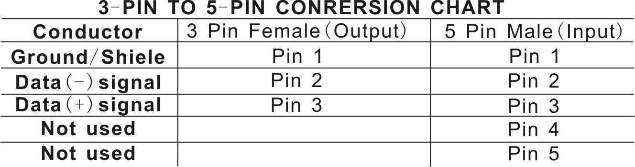

PART 3 Display Panel Operation
3.1 Display panel menu instruction
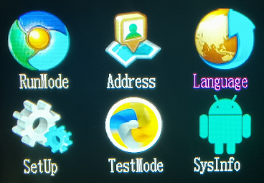
[MENU] menu selection or return to previous menu.
[ENTER] confirm & quit out current function setting.
[UP] press [UP] through the menu list to increase/change the value of the current function.
[DOWN] press [DOWN] through the menu list to decrease/change the value of the current function.

  - Display Menu instruction (general)
Show | Function | Item 1
Run Mode | Channel Mode | 4 Channel
Run Mode | Channel Mode | 6 Channel
Run Mode | Channel Mode | 9 Channel
Run Mode | Auto-program | AUTO1 AUTO2 AUTO3
Run Mode | Speed | 0-100
Run Mode | Red | 0-255
Run Mode | Green | 0-255
Run Mode | Blue | 0-255
Run Mode | White | 0-255
Address | 001-512
Language | 中文
Language | English
Setup | Dimming Mode | 8bit/16bit
Setup | Signell Link | Off~ON
Setup | Temperature | 50~85
Setup | Screen Protect | Off~ON
Setup | Screen Rot | Off~ON
Setup | Logo | Off~ON
Setup | Red Current | 235
Setup | Green Current | 235
Setup | Blue Current | 235
Setup | White Current | 235
Setup | Factory Set | Off~ON
Test Mode | Red | 0-255
Test Mode | Green | 0-255
Test Mode | Blue | 0-255
Test Mode | White | 0-255
Sysi Info | Dmx Address
Sysi Info | Running Mode
Sysi Info | OnTime
Sysi Info | RunTime
Sysi Info | Temperature | 000
Sysi Info | SoftVer | XF02

