FLASHER 400 strobe light
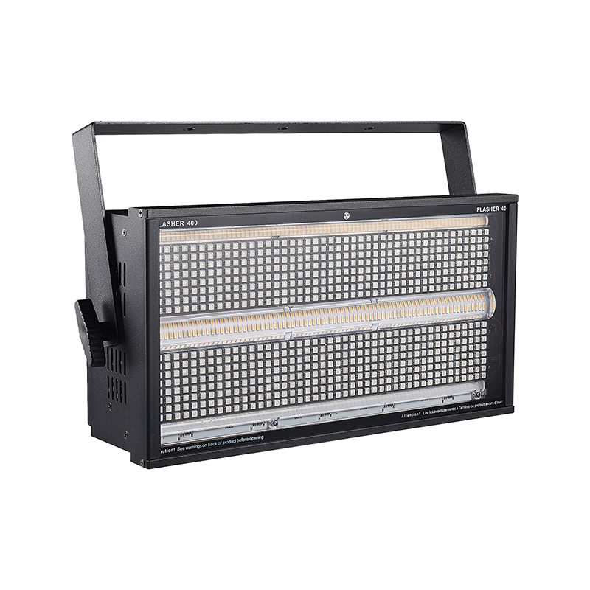
User Manual

(Please read the instructions carefully and manage them properly before using the product)

catalogue

Chapter 1 Precautions and Installation 1
1. Remove packaging 1
2. Safety Instructions 1
3. Product precautions 2
4. Installation of lighting fixtures 2
Chapter 2 Panel Operations 5
1. Lamp panel 5
2. Menu interface 5
2.1. System Settings 6
2.2. System Calibration 8
2.3. Manual mode 9
2.4. System Information 10
Chapter 3 Channel Description and Technical Parameters 10
1. Channel Table 10
2. Technical parameters ..........................................................................................................41
Chapter 4 Common Malfunctions and Precautions for Use ......................................................................................42
1. Common fault handling 42
2. Precautions for use 43
3. Precautions for RDM Use 44

- Precautions and Installation

1. Remove the packaging

To use this product correctly and safely, please read the instructions carefully before installing and using it. This manual contains important installation and application information. Please strictly follow the operating steps in the manual when installing and operating the product. Meanwhile, please keep this manual properly.
FLASHER 400 strobe lights are designed and produced strictly in accordance with CE standards, and comply with the international standard DMX512 signal protocol. They can be used separately or online, with high brightness, low noise, and powerful functions. They are suitable for small and medium-sized concerts, theaters, studios, nightclubs, bars, and other places.
Please be careful when removing the packaging. After removing the packaging, check if the product has been damaged during transportation and ensure that the following information is complete.

FLASHER 400 strobe light -1 signal line -1 line
Instruction manual -1 power cord -1 piece

The product is not equipped with relevant repair parts. The maintenance and repair of the product can only be carried out by professionals!
Please do not modify this product without authorization, otherwise it may damage the product, and any damage caused as a result is not covered by the warranty. Moreover, unprofessional operations may lead to short circuits, burns, electric shocks, and so on.

2. Safety instructions

be careful! Please be cautious before operating this product. This product is a high-voltage product, and if it comes into contact with wires, it may cause electric shock!
This product is in good condition before leaving the factory. To maintain the integrity of this product and ensure safe operation, users are advised to follow the safety precautions and warnings in this manual.
Important: Damage caused by failure to follow this manual is not covered by the warranty. The supplier is not responsible for any product issues caused by this.
If the product has been exposed to extreme and unstable temperature environments (such as after transportation), please do not immediately connect the product power supply, as water droplets generated due to temperature changes may damage the product. Please use the product only after it has returned to normal temperature.
This product can be used within the voltage range of 90-240V and is intended for indoor use. Please ensure that the ground voltage used is not higher than the range that the product can withstand!! The power plug must be plugged into a Class I socket with good protection. The green or tea green conductor must be grounded.
Please check the power cord of this product regularly. Ensure that the power cord is not folded, damaged, or scratched, and is not connected to other wires! Special attention should be paid when connecting power cords or related connections. Be sure to unplug the power supply when not using this product or before cleaning.
Before using the product, please familiarize yourself with its operating functions. Please do not allow children or non professionals to come into contact with the product.
Please do not shake this product. Do not use brute force when installing or operating the product. Do not allow non professionals to operate the product. Most of the damage is caused by unprofessional operation.
The product is not equipped with relevant repair parts. The maintenance and repair of the product can only be carried out by professionals!
Please do not modify this product without authorization, otherwise it may damage the product, and any damage caused as a result is not covered by the warranty. Moreover, unprofessional operations may lead to short circuits, burns, electric shocks, and so on.

3. Product precautions

If the product has gone through a large temperature difference (such as after transportation), do not start the product immediately because thermal shrinkage can damage the product. Please wait until the device reaches normal room temperature before starting the product.
● Pay attention to shock resistance. Avoid strong collisions during product installation.
Please do not lift the entire product through the lamp head, as this may damage the mechanical properties of the equipment.
When selecting the installation location, please ensure that the product is not exposed to excessive heat, moisture, or dust. Please do not place any wires on the ground, otherwise there may be a risk of electric shock.
Before installing the product, please ensure the safety of the installation point.
Please fasten the product with a safety rope and check if all screws are correct during installation.
Please ensure that the lens is in good condition. When the lens is damaged or scratched, please replace it.
It is recommended that technicians familiar with this product operate it. Non technical personnel are prohibited from operating this device, as many losses are the result of non professional operations.
Please keep the packaging materials properly in case of secondary transportation.
Do not change the product without the guidance of the manufacturer or distributor.
Any equipment malfunction caused by failure to operate and use this device according to the instructions is not covered by the warranty. And any accidents caused by short circuits, injuries, electric shocks, UV damage, bulb explosions, etc. are not covered by the warranty.

4. Installation of lighting fixtures

Attention: For safety reasons, please hang and install this product away from corridors, seating areas, or areas within reach of human hands.
This lamp can be placed horizontally, hung diagonally or upside down. When hanging diagonally or upside down, be sure to pay attention to the installation method Fixed installation of lighting fixtures: Before positioning the lighting fixtures, it is necessary to ensure the stability of the installation site. When reversing the hanging installation, it is necessary to ensure that the lighting fixtures do not fall off the support frame. Safety ropes should be used to thread through the support frame and lighting fixture handle for auxiliary hanging; To ensure safety To prevent the lamps from falling and sliding, pedestrians are prohibited from passing underneath during installation and debugging. Regular inspections should be conducted to ensure that the safety ropes are not worn and the hook screws are not loose. If the lamps fall due to unstable hanging installation, the manufacturer shall not be held responsible for any consequences.
Before hanging this product, please ensure that the installation point can withstand 10 times the weight of this product.
The product installation must have dual protective devices, such as safety ropes.
When hanging, dismantling or repairing this product, it is forbidden to stand under the installation point.
Please ensure that this product is installed at least 0.5 meters away from flammable materials.
Hanging point: The top hanging requires experienced installation personnel, including calculating load-bearing requirements, using installation materials, and periodically checking the safety status of installation materials and products. If you lack this knowledge, please do not attempt to install it yourself. If not operated correctly, it may lead to serious consequences such as personal injury.
Before powering on the product, please ensure that all required hanging and installation steps are completed.
Quick lock suspension: This product has specially designed professional suspension components at the bottom, including quick lock suspension components and safety rope suspension points (please refer to the following figure).
When hanging this product on a truss, please remember to use a suitable quick lock to secure it in the position of the product's quick lock hanger, and use M10 screws to hang it up. To further ensure safety, please install the safety rope at the safety rope hanging point at the bottom of the product and fix it on the truss.
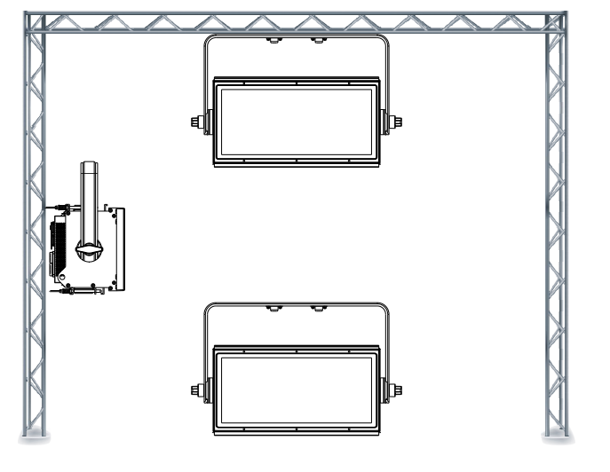
Figure 1 Schematic diagram of lamp installation
No matter which type of hanging you choose, please remember to use a safety rope. The bottom of the product is equipped with a dedicated safety rope hanging point, please refer to the above picture, and please remember to use the specially provided safety rope hanging point. Do not install the safety rope at the handle position.

DMX-512 connection
This lamp uses DMX512 signal control mode, and the control signals of each lamp are in parallel. When connecting multiple lamp signals, it is best to use dual core shielded cables When connecting, each lamp is connected through the DMX signal socket (XLR socket) INPUT and OUTPUT on the lamp. The 3-core XLR plug terminals of the signal line connecting the lamp must correspond to each other. When connecting the lamp signal, it is recommended to use a DMX signal terminator To avoid damage to control signals caused by electrical noise, the DMX signal terminator is an XLR plug with a 120 ohm 1W resistor connected between pin 2 and pin 3, and connected to the OUTPUT socket of the last light fixture.
Calculation method for starting address code of lighting fixtures:
The starting address code of the current lamp is equal to (the starting address code of the previous lamp)+(the number of channels of the lamp). Explanation:
1: The starting address code value of the first lamp is A001.
2: The basic channel number of the controller should be greater than or equal to the total number of channels used by the lamp.
3: Attention: When using any controller, each lamp must have its own starting address code. If the starting address code of the first lamp is set to A001 and the number of channels is 16CH, then the starting address code of the second lamp should be set to A017; The starting address code of the third lamp is set to A033; And so on, (this setting method also needs to be determined according to different consoles).
Please plug the male end of the XLR signal cable provided with this product into the signal output port of the controller, and the female end into the signal input port on the back panel of this product. You can connect multiple products in series, and the signal line needs to be three core, shielded, with XLR input and output heads. Please refer to the following diagram.
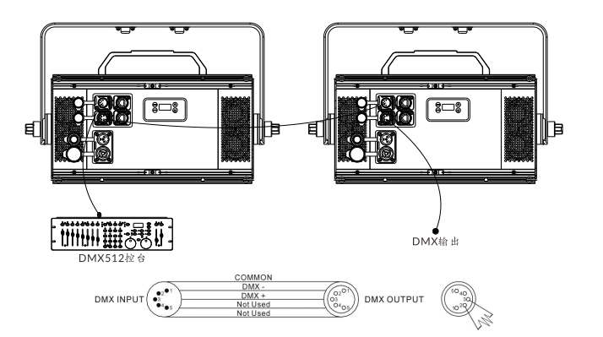
Figure 2 Schematic diagram of DMX512 connection

- Panel operation

Lamp panel
The schematic diagram of the lighting panel is shown in Error: Reference source not found:
1) Signal light: When the lamp is connected to the control panel, the display screen will turn off, and the display screen will flash when there is no signal.
2) Temperature: As shown in the figure, the temperature of the lamp board is 30 degrees Celsius; If the temperature displays --- ℃, the temperature detection of the lamp is abnormal. Possible open circuit in the temperature control connection line. If the temperature displays * * * ℃ and there is a significant difference from the ambient temperature, it may be a short circuit in the temperature control connection wire. Professional maintenance and troubleshooting are required before normal use can be achieved.
3) Address code: The display range is 001-512, and the address code shown on the diagram is 001.
4) DMX mode: 512 mode.
5) Button: UP: Up button
MENU: Return key
ENTER: Confirm button
DOWN: Down key
Attention: Do not use sharp or pointed objects to click on the display screen to prevent damage.
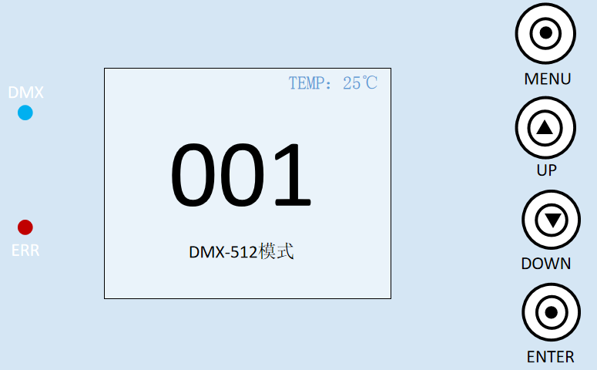
Figure 1 Schematic diagram of four key display panel

Menu interface
The menu header contains 6 sub menus. Select the corresponding sub menu by pressing the "UP" and "DOWN" keys, and click the "ENTER" key to enter the corresponding sub menu interface. The menu header interface is shown in Figure 4:
- Address: Click to enter the address code settings, and use the "UP" and "DOWN" keys to increase or decrease the number of address codes by one digit. At this time, the address code displayed on the lighting panel will also be updated synchronously.
2) Settings: Click on the system options to change the working mode, working parameters, and panel display settings of the lighting fixtures.
3) Test: Click to enter manual mode and control the functions of the lighting fixtures. Please refer to the channel table for specific details.
4) System: Click to enter and view information such as software and hardware versions.
5) Advanced: Click to enter and view information such as software and hardware versions.
6) Information: Click to view system error correction, software and hardware versions, and other information.
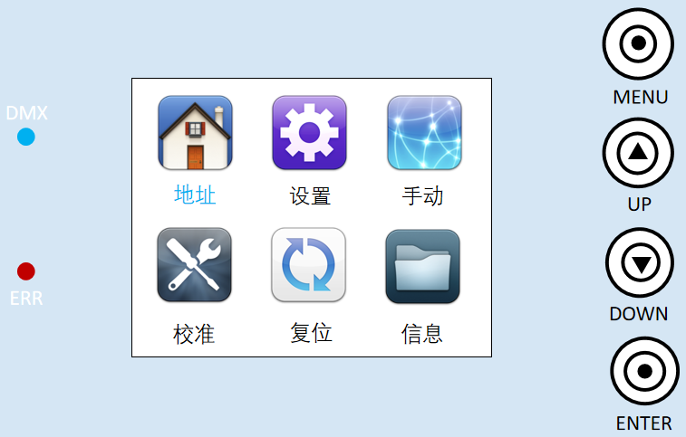
Figure 4 Determine input window

2.1 System Settings
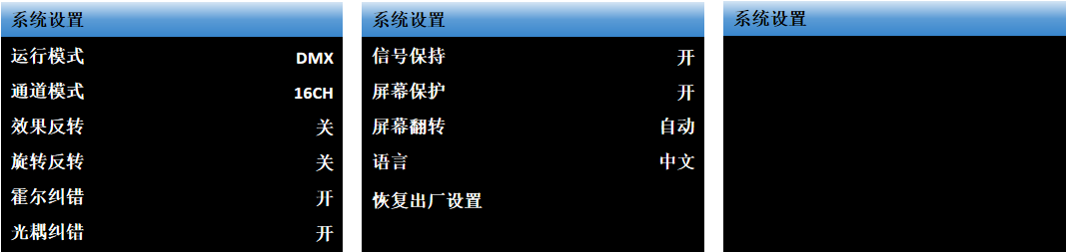
Figure 5 System Settings Window
The system settings interface is shown in Figure 5. Enter the system settings, click the "ENTER" key to select the settings that need to be modified, then use the "UP" and "DOWN" keys to select the changes, and finally confirm with the "ENTER" key to change the working mode, working parameters, and panel display settings of the lighting fixtures. The specific details are shown in Table 1.
option | describe
Working mode | Lamp working mode: DMX/voice control/self-propelled 1/self-propelled 2
Working mode | DMX mode | Console mode, receiving DMX signals
Working mode | Self driving mode | The lamp automatically runs according to the built-in self-propelled program
Working mode | Audio Mode | When the light fixture detects strong sound, it automatically runs a scene according to the built-in program, otherwise it maintains the last scene
Channel Mode | 5CH/16CH/324CH
effect | Built in effect of LED beads
effect | 000 | Go through all the effects once
effect | 001-288 | Choose to use a single effect
speed | Speed of built-in effects
speed | 001-100 | Speed from slow to fast
style | 001-255 graphic
LOOK | open | Yellow non-stop screen/Blue no operation, screen will turn off after ten seconds
Screen Flip 180 | close | Screen forward
Screen Flip 180 | open | Screen reversed
language | Chinese/EN
Restore factory settings | Lamp parameters return to factory settings
Restore factory settings | cancel | Keep it as it is
Restore factory settings | confirm | Lamp restored to factory settings
Table 1

main menu | Secondary menu | Third level menu/parameters
address | 001 - 512 | (Add channels each time, subtract normal)
System settings | Operating mode | DMX/self-propelled/voice controlled
System settings | Channel Mode | 5CH/16CH/324CH
System settings | effect | 0-288
System settings | speed | 1-100
System settings | style | 0-255
Test mode | All color brightness and effect flicker | Manually control all color brightness and effect flicker
system information |  | View information such as software and hardware versions
senior | Factory settings | OFF/ON Restore factory settings

Table 2

- Channel description and technical parameters

Channel Table

5-Channel Mode (Mode 1):
Channel 5 | channel value | basic function
1 | 000-255 | R red light bead dimming
2 | 000-255 | G green light bead dimming
3 | 000-255 | B Blue LED Dimming
4 | 000-255 | W white light bead dimming
5 | 000-255 | Y yellow light bead dimming

16 channel mode (Mode 2):
Channel 16 | channel value | basic function
1 | 000-255 | Total dimming
2 | 000-255 | RGB strobe
3 | 000-255 | Reverse pole
4 | 000-255 | RGB color bar
5 | 000-255 | Character bar
6 | 000-255 | RGB effect, 255 for voice control
7 | 000-255 | RGB speed
8 | 000-255 | WY strobe
9 | 000-255 | WY color
10 | 000-255 | WY effect
11 | 000-255 | WY speed
12 | 000-255 | R red light bead dimming
13 | 000-255 | G green light bead dimming
14 | 000-255 | B Blue LED Dimming
15 | 000-255 | W white light bead dimming
16 | 000-255 | Y yellow light bead dimming

324 channel mode (mode 3):

Channel 324 | channel value | basic function
1 | 000-255 | Linear dimming of red light bead in the first segment of R
2 | 000-255 | Linear dimming of green light bead in the first segment of G
3 | 000-255 | Linear dimming of blue light bead in the first paragraph of B
  …
  …
  … …
262 | 000-255 | Red LED linear dimming in segment 88 of R
263 | 000-255 | Linear dimming of green light bead in segment 88 of G
264 | 000-255 | B Section 88: Linear Dimming of Blue LED Bead
265 | 000-255 | W 1st segment white light bead dimming
266 | 000-255 | Y 1st segment yellow light bead dimming
  …
  …
  … …
233 | 000-255 | W 30th segment white light bead dimming
234 | 000-255 | Y 30th segment yellow light bead dimming

- Common faults and usage precautions

Common fault handling
The lamp contains professional components such as microcomputer circuit boards and high-voltage power supplies. For your safety and product lifespan, non professionals are not allowed to disassemble the lamp and related accessories without authorization.

The light bulb does not light up (except for LED light sources)
Possible reasons: The bulb has not completely cooled down, or the bulb has reached its lifespan. The following measures should be taken:
- Due to abnormal operation, the bulb has not completely cooled down. The lamp body should be allowed to cool for more than 10 minutes to fully restore its internal normal state, and then the power should be restarted;
- Check if the light bulb has reached its service life and replace it with a new one;
- Check if there is any leakage, detachment or poor contact between the light bulb and the lighting circuit;
- Replace the lamp with a new one.

The light bead appears dim
Possible reasons: The LED beads have been used for a long time or the light path is not clean. The following measures should be taken:
- Check if the lamp beads have reached their service life and replace them with new ones;
- Check whether the optical components or light bulbs are clean, whether there is dust accumulation on the light bulbs and other optical components, and regularly clean and maintain the lamp beads and various components inside the lamp.

Pattern projection blurred
- Check if the electronic focus channel value is appropriate for the current projection distance.

The lighting fixtures work intermittently
Possible cause: The internal circuit has entered a protected state. The following measures should be taken:
- Check if the fan is running normally or if it has become dirty, causing an increase in the internal temperature of the lighting fixture;
- Check if the internal temperature control switch is in the closed state;
- Check if the light bulb has reached its service life and replace it with a new one.

The lamp does not accept control from the console after normal reset
Possible reasons: Signal line malfunction or abnormal lighting parameter settings. The following are the solutions:
- Check the starting address code and the connection status of the DMX signal cable (whether the signal cable is intact and whether the connector is loose);
- Add a signal amplifier and a 120 ohm terminal resistor;

The lamp cannot be started
Possible cause: Poor power supply circuit. The following measures should be taken:
- Check if the fuse on the power input socket is blown and replace the fuse;
- Poor contact of the circuit caused by vibration during long-distance transportation of lighting fixtures
- Check the input power supply, computer board, and other plug-in components.

Precautions for use
- Check whether the local power supply meets the rated voltage requirements of the product, and whether the leakage protector, overcurrent protector, etc. meet the load requirements carried;
- Do not use power cords with damaged insulation layers, and do not overlap power cords with other wires;
- The lighting fixtures use strong wind cooling, which is prone to dust accumulation. Therefore, it is necessary to clean them once a month, especially the heat dissipation vents, otherwise they may be blocked by dust accumulation, resulting in poor heat dissipation and abnormal lighting fixtures.
- When installing lighting fixtures, the fixing screws must be tightened and equipped with safety ropes, and checked regularly;
- When installing and positioning the lamp, any point on the surface of the lamp should be kept at a minimum distance of 10 meters from any flammable or explosive material, and at a distance of 2.5 meters from the illuminated object. Please do not directly install the lamp on the surface of flammable materials;
- It is recommended that the continuous working time of the lamp should not exceed 10 hours, and the interval between continuous starting of the lamp should not be less than 10 minutes, otherwise it may not be triggered properly due to bulb overheating protection;
- The closing time of the switch valve should not exceed 5 minutes. If it is necessary to close the light for a long time, the control panel (lamp control channel) should be used to turn off the lamp;
- In order to ensure that multiple lighting fixtures better comply with the scene effect, the lighting fixtures should not be in an unfinished state of the current scene, that is, starting the next scene action. It is best not to exceed 3 minutes in this state to ensure that multiple lighting fixtures can run synchronously;
- During use, if there are any abnormalities in the lighting fixtures, they should be stopped in a timely manner to prevent the occurrence of other malfunctions.

Precautions for using RDM
RDM is an extended version of the DMX512-A protocol, which is a remote device management protocol. Traditional DMX512 protocol communication is one-way, and the protocol is based on the RS-485 bus. RS-485 is a time-sharing multi-point, half duplex protocol that allows only one port to be the host output at a time. Therefore, when using RDM, the following points should be noted:
- To use a console or host device that supports RDM protocol host;
- To use a bidirectional signal amplifier, traditional unidirectional signal amplifiers are not suitable for the RDM protocol because the RMD protocol requires feedback data. Using a unidirectional amplifier will block the returned data, resulting in the inability to search for lighting fixtures;
- All lighting fixtures must be set to DMX mode to ensure that there is only one host on the signal line;
- A 120ohm impedance matching resistor must be inserted between terminals 2 and 3 of the terminal plug. When the signal line is relatively long, reducing signal reflection will make differential signals more stable and beneficial for communication quality;
- When a light fixture is controlled by DMX but cannot be searched by RDM, first check the signal amplifier, and then check if there is a poor contact between the 2 and 3 wires of the signal line.

