Laser Beam

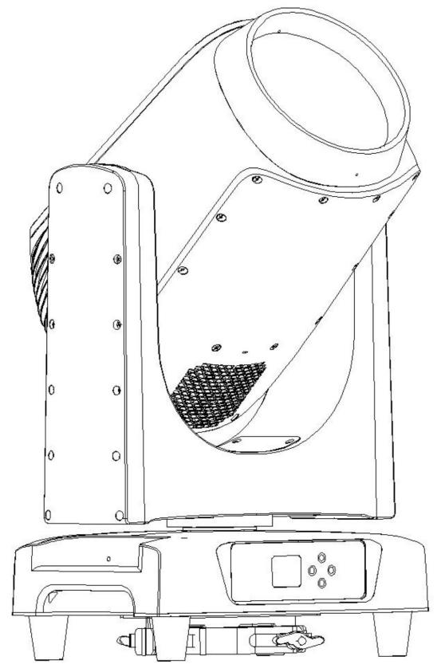

USE MANUAL

Catalogue

Safety guide............................................................................3
Specification parameters.........................................................4
Insall........................................................................................6
Power connection....................................................................7
Signal connection....................................................................9
Lighting setting........................................................................10
Channel data...........................................................................15
Control line diagram................................................................18
Maintenance guide..................................................................19

Thank you very much for purchasing this product. Before you use our product, please carefully read carefully and fully understand all the safety instructions
recorded in this book to avoid the potential dangers that may cause bodily injury,
property damage or damage to the product. The Company shall not be liable for any direct losses and associated losses caused by the failure to operate as instructed in the instructions.


SAFETY GUIDE
WARNING

Please read the instruction manual carefully, which contains important information about installation, operation, maintenance, etc
This product is intended for professional use only and is prohibited for family use
Please keep this manual for future reference, if you sell the machine to another user, please ensure that the user also gets this manual.
u Open the package before use and carefully check if the machine is damaged during transportation.
u Non-professional operators are not allowed to install and operate the machine.
u Disconnect the external power supply when opening the housing or replacing the parts, or when the lamp is not in use.
u Ensure that the equipment is reliable and use the AC power supply matching the lamp voltage frequency with overload and grounding protection.
u Before use, ensure that the cable is in normal condition and suitable for the flow of the connected equipment.
u Avoid having the power cord going around with the surrounding cables.
u Ensure that the equipment is reliably grounded.
u If the power cable or plug is damaged, the lamp is wet or the power supply is obviously overheated, please disconnect the power supply immediately.
u Avoid any flammable liquid, water, or metal material from entering the machine. Once it happens, please cut off the power supply immediately.
u Do not look directly into the light port and the illuminated light source.
u Do not use damaged housing, light shield, lens, protective screen, or heat lamps.
u If the protective screen, lens or ultraviolet screen on the lamp produces visible damage, that is, the damage to the degree of failure, such as cracks or deep marks, should be replaced in time.
u Do not use when the ambient temperature exceeds 40℃ .
u When the external temperature of the lamps during the use is 65℃, to avoid contact with the human body or other objects. Please cool the lamps fully before handling.
u Ensure that combustible materials (such as fabric, wood, paper, etc.) away from the lamps at least 0. 5 meters, flammable items as far as possible away from the equipment, ensure that the inlet and outlet at least 0. 5 meters of space
u Do not directly illuminate surfaces within 10 meters.
u During the day, cover the lens or turn the lens direction to prevent direct sunlight from reaching the lens, as it can focus on the sun and create a potential fire hazard.
u In any case, do not modify the lamp, do not install non-original parts, do not paste any filter paper on the lens or other optical accessories.
u Disconnect the power supply before maintaining the clean lamps.
u Do not attempt to short circuit the fuse or the temperature control switch.
u Do not carry the lamps and lanterns alone when working at a height.
u Use two evenly distributed lamp hooks on the hanger, and do not use a single lamp hook.
u Ensure that the support and hanging system can support more than 10 times the weight of the lamp.
u When used, a safety rope must be installed, which must be able to withstand 10 times the weight of the lamp.
u Ensure that the external fittings and hangings are fully fastened.
u For installation, maintenance and moving lamps, stable platform shall be provided with safety fence.
u For related operations not described in this article, please consult the Authorized after-sales department.

Specification parameters

Voltage: AC100-240V 50 / 60Hz
Maximum power: 400W
Light source: a 300W white laser light source
Light source life: 12,000 hours
Control: 14 / 16 channel, DMX512, RDM.
Color: one color plate, 14 colors + white light, half-color and two-way color rainbow effect
Pattern: a fixed pattern plate, 19 kinds of patterns + white light, running water, jitter effect
Prism: 8 prism + 24 prism: can be two-way rotation, can switch independently, can stack
Optics: high-precision glass optical lens, optical diameter of 165mm, electric focus
Effect: nebulization effect
Movement: horizontal 540 degrees, 8 / 16 Bit resolution, 360 degrees infinite rotation 252 degrees vertical, 8 / 16 Bit resolution
Vertical magnetic encoder; three-phase stepper motor
Display: 1.7-inch display screen, touch button, Chinese and English interface.
Software upgrade: Software can be updated through a DMX connection
Waterproof power supply connector input / output
Three-core / five-core waterproof Canon head socket Fold hook is free
Protection level: IP66
Dimensions: 348 * 250 * 624mm
Net weight: 21.6Kg

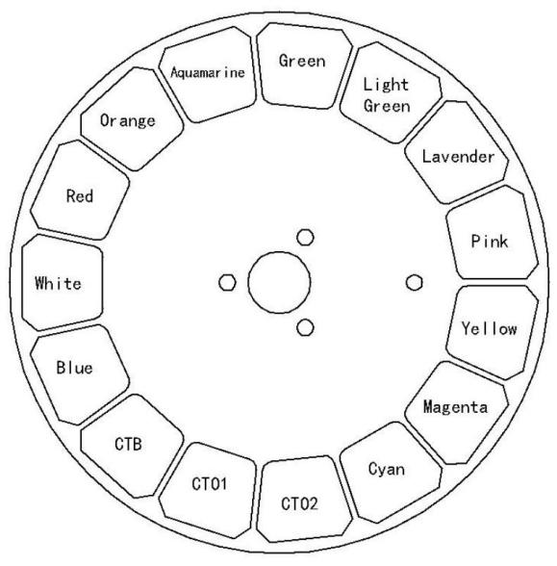
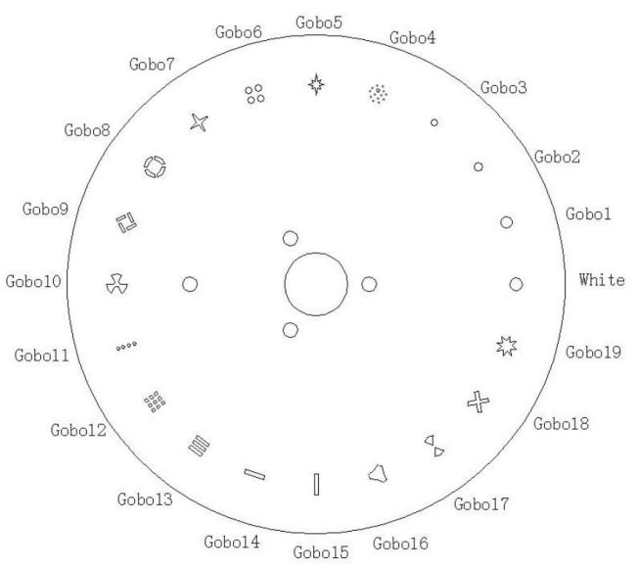

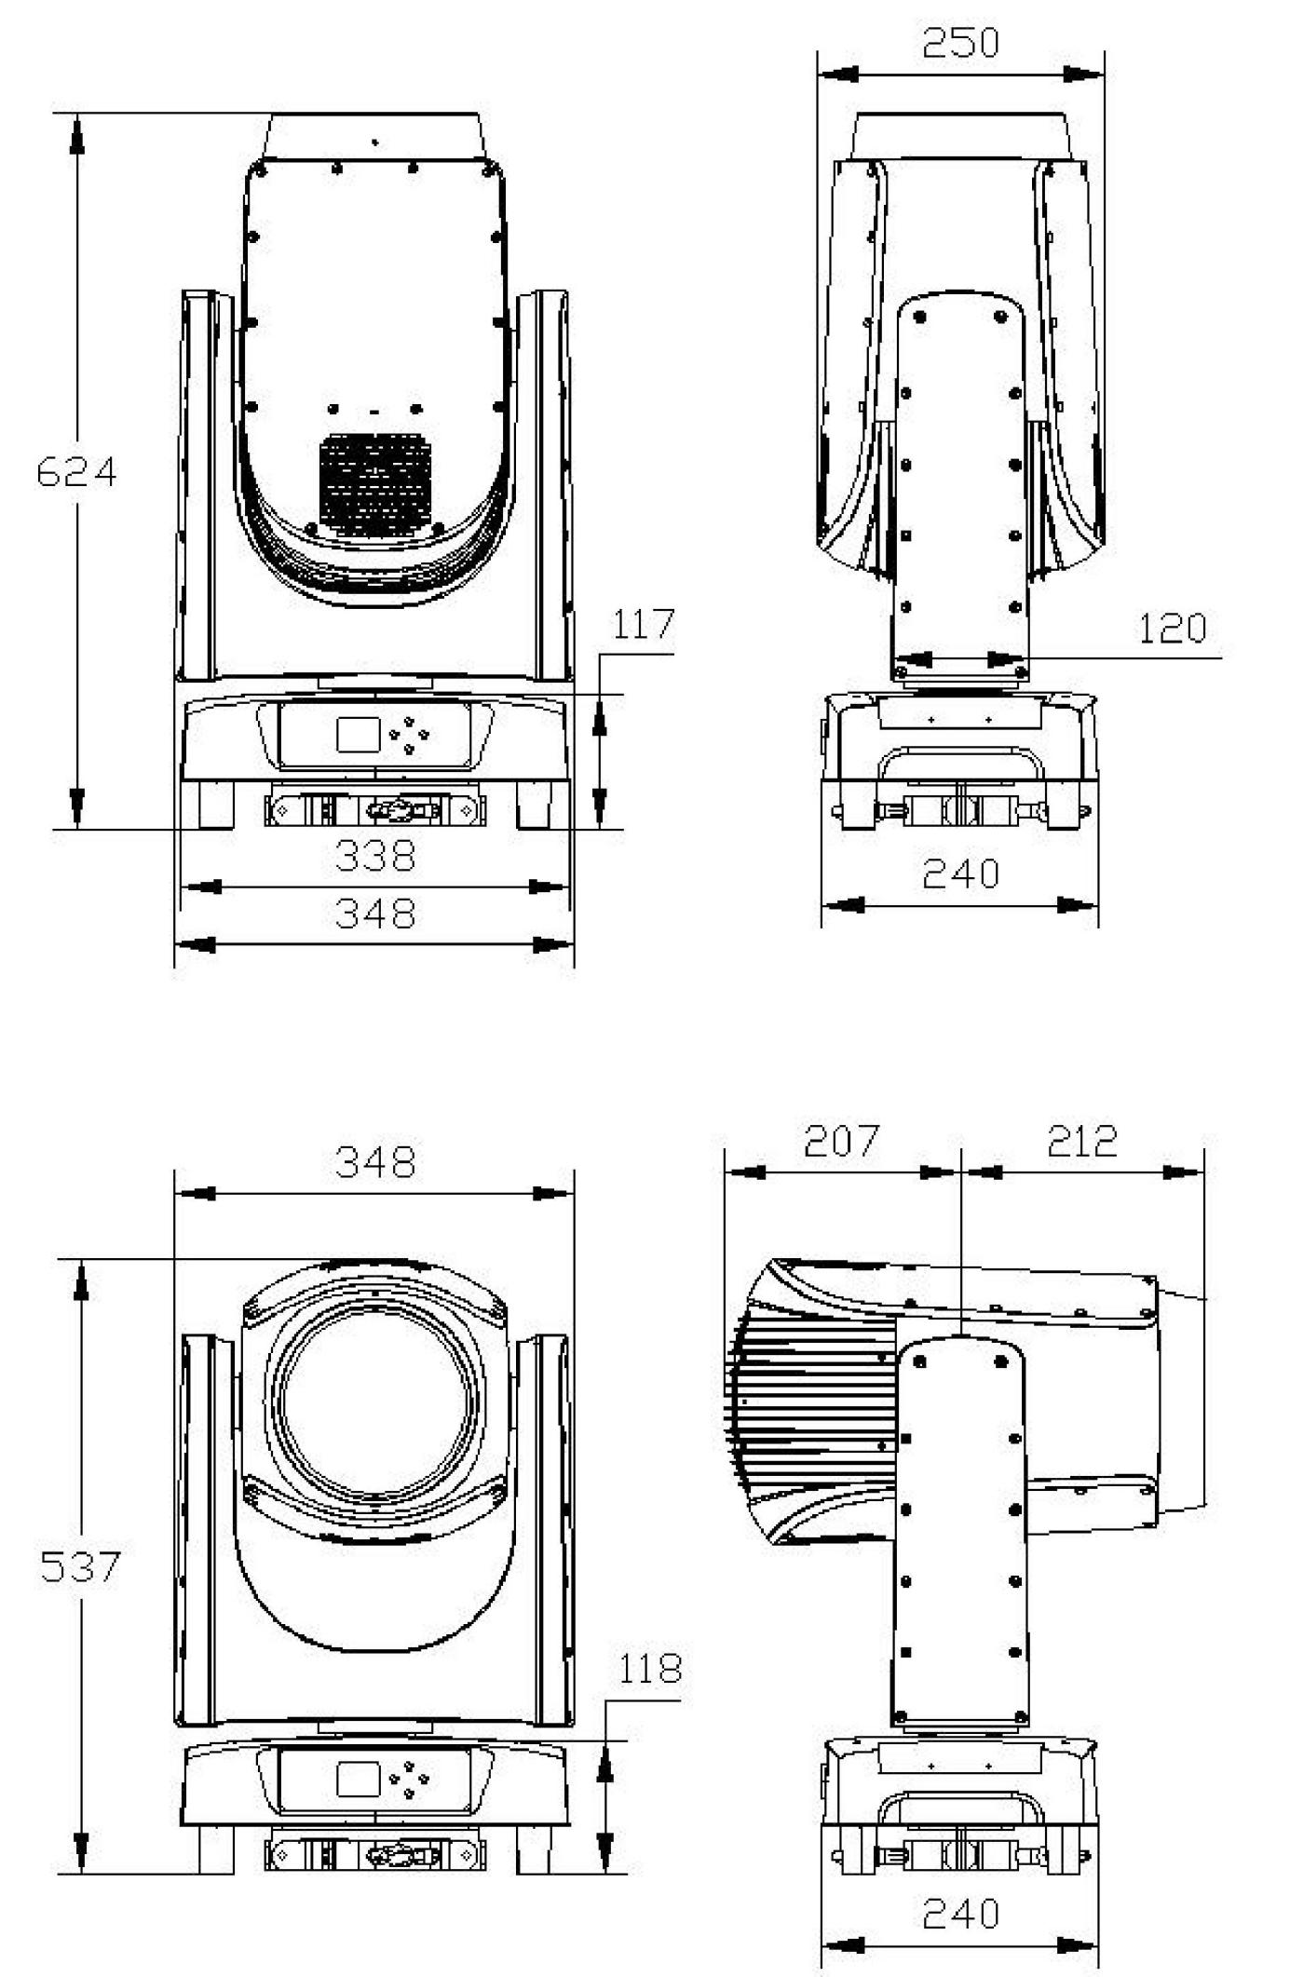

INSTALL

Δ | WARMING:  When hanging lamps, additional safety rope must be installed to prevent the failure of lamp hook,
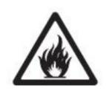
The safety rope must be attached to the mounting position of the safety rope, and must not be installed on the handling handle
When the lamp is not placed steadily, the movement of the lamp head may drive the movement of the base,
Therefore, do not start the lamp without confirming the stable placement or hanging of the lamp.
Do not hang the side installation and use of lamps!
Cover the lens or turn the direction to avoid direct sunlight into the lens,
Because the camera can focus on sunlight as a potential fire danger.
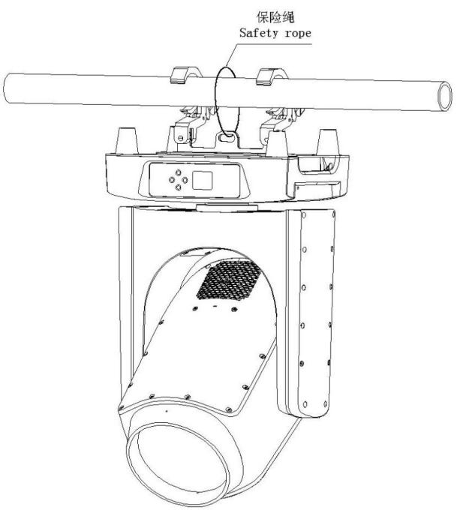
Installation considerations:
1． Confirm that the hanging lamp hook and accessories are not damaged and can withstand 10 times the total weight of the lamps, cables and accessories,
2． For installation, maintenance and moving lamps, stable platform shall be provided with safety fence
3． Tie the safety rope through the hole in the lamp base to the lamp holder, not to the handle
4． Check that there is no combustible material within 0. 5 meters of the lamp shell, do not be blocked within 10 meters of the lamp column directly, and no flammable substances nearby
5． Check that the lights are not possible to collide with each other during movement
6． Check that the other lamp has not directly illuminate on the lamp, the strong light will damage the protective shell of the lamp
7． Make sure that the installation surface is horizontal, so as to avoid sliding when the lamp is running


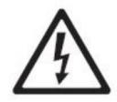
warn:
To prevent electric shock, the lamp must be grounded, and the main power supply must be safe and disconnected
Switch and ground protection

Please connect the lamp directly to AC power supply, not the silicon box to avoid damage
lamps and lanterns

When the power supply of the lamps is connected in series, the maximum current of the power supply seat shall not be greater than 1 6 A
Power connection
A plug matching with the lamp power interface has been installed on one end of the power cord, and a suitable power plug with grounding shall be installed on the other end. Installation must follow the manufacturers instructions. The table below gives some tips for plug and pin connections. If not sure or questionable, consult a qualified electrician.

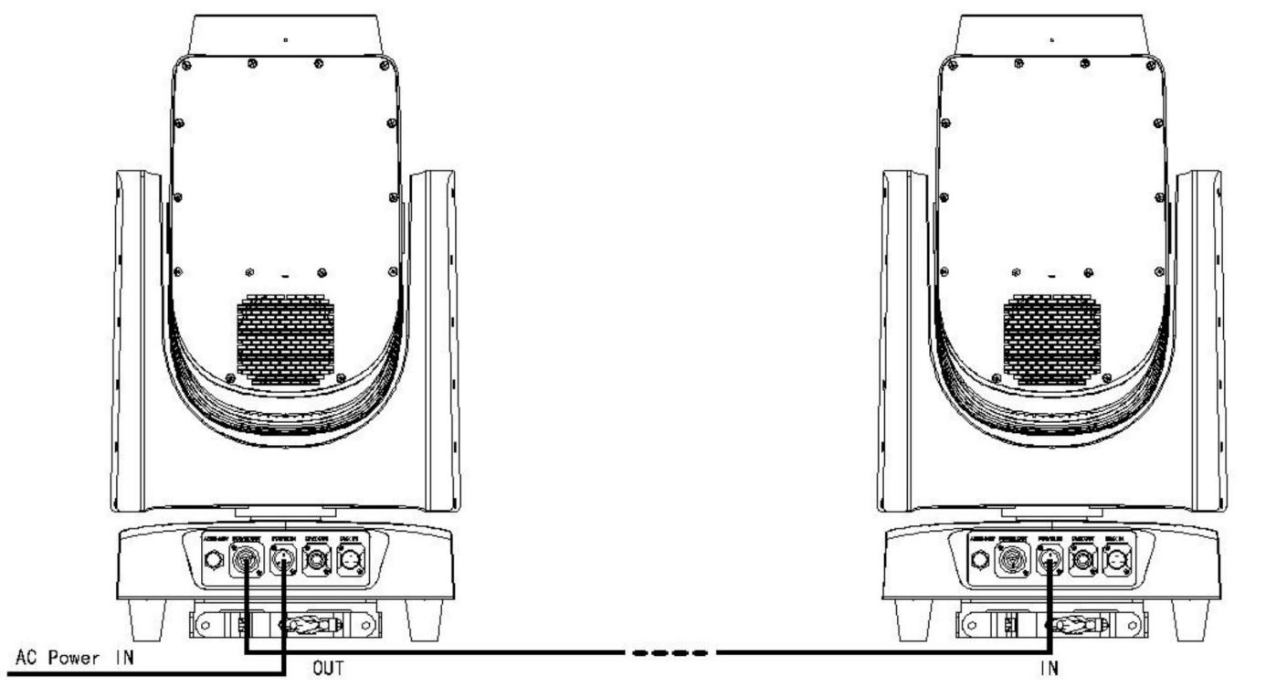
AC100V The power cord can connect up to 4 lamps in series
AC220V The power cord can connect up to 8 lamps in series

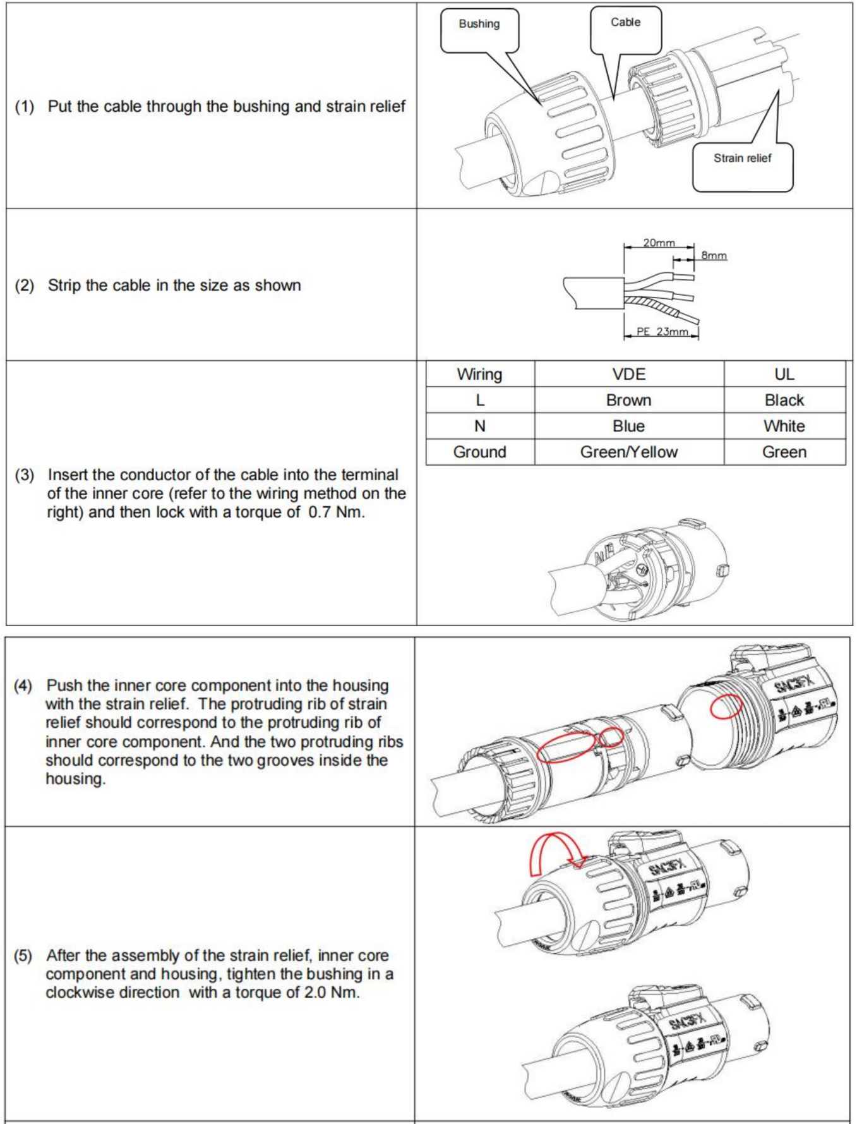

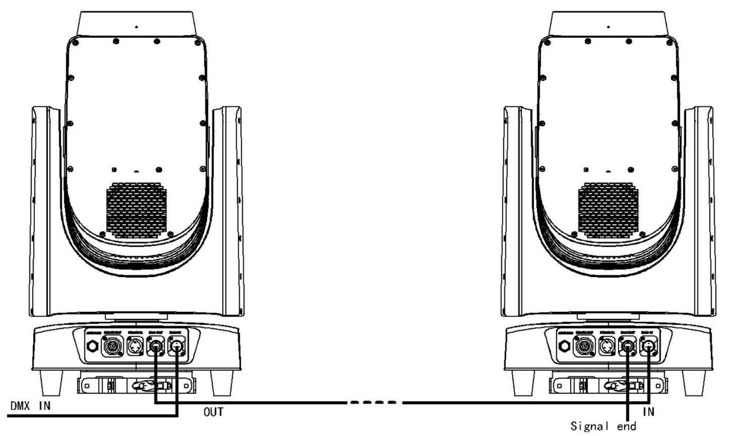

Signal connection
DMX signal via XLR Cannon insert, defined as follows:
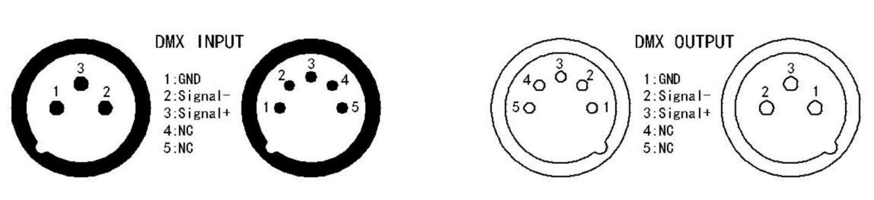
1. Connect a DMX signal line from the controller to the lamp signal input port
2. Connect one DMX signal line to the next lamp from the lamp signal output port
3. The DMX signal line can only be connected in series. In parallel, please use the signal distributor
3. Interspan a terminal resistance between the 2 and 3 feet of the last lamp signal output
Reliability tips
l Using a shielded twisted pair designed for RS-485, the connection distance of the signal is generally 150 meters, and a signal amplifier is used for long-distance transmission
l Branch driver (signal in parallel) requires a signal distributor
l A 120 ohm 1 / 4 watt resistance is crossed between the 2 and 3 feet of the last lamp signal output to avoid signal reflection interference, so that the resistance should be connected to the respective terminals

Lighting setting
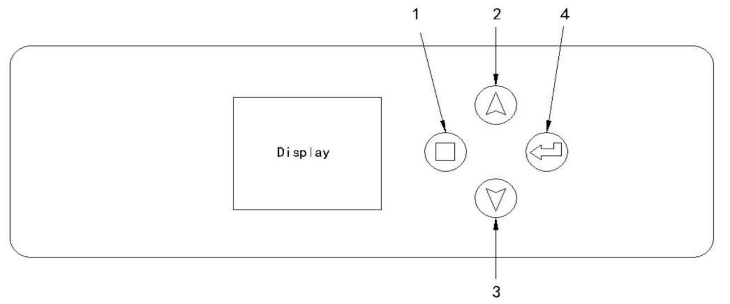
l 1- -MENU (menu key) 2- -UP (upper key) 3- -DOWN (lower key) 4- -ENTER (confirmation key)
l Key lock: touch the menu button and confirmation button in 3 seconds

Menu structure

DMX地址  DMX Addr | 红色背景时地址码加减1，黑色背景时地址码按通道模式加减
通道模式  Channel Mode | 16
通道模式  Channel Mode | 14
运行模式  Run Mode | DMX
运行模式  Run Mode | 用户  User
运行模式  Run Mode | 自走  Auto
手控  Manual | 锁定手控  Lock Manual Ctrl | 否  No
手控  Manual | 锁定手控  Lock Manual Ctrl | 是  Yes
手控  Manual | X轴  Pan
手控  Manual | Y轴  Tilt
手控  Manual | X轴旋转  Pan Rot
手控  Manual | 颜色  Color
手控  Manual | 频闪  Strobe
手控  Manual | 调光  Dimmer
手控  Manual | 固图  Gobo
手控  Manual | 棱镜  Prism
手控  Manual | 棱镜自转  Prism Rot
手控  Manual | 雾化  Frost
手控  Manual | 调焦  Focus
复位  Reset | 整机复位  Reset All
复位  Reset | XY轴  Pan Tilt
复位  Reset | 头部复位  Head Reset
运行设置  Run Settings | 主从模式  M/S Mode | 从机  Slave
运行设置  Run Settings | 主从模式  M/S Mode | 主机  Master
运行设置  Run Settings | XY轴设置  Pan/Tilt Settings | X轴反向  Pan Reverse | 否  No
运行设置  Run Settings | XY轴设置  Pan/Tilt Settings | X轴反向  Pan Reverse | 是  Yes
运行设置  Run Settings | XY轴设置  Pan/Tilt Settings | Y轴反向  Tilt Reverse | 否  No
运行设置  Run Settings | XY轴设置  Pan/Tilt Settings | Y轴反向  Tilt Reverse | 是  Yes
运行设置  Run Settings | 调光曲线  Dim Curve | 线性  Linear
运行设置  Run Settings | 调光曲线  Dim Curve | 对数  Log
运行设置  Run Settings | 调光曲线  Dim Curve | S曲线  S-Curve
运行设置  Run Settings | 调光曲线  Dim Curve | 开方  Square Root
运行设置  Run Settings | 调光曲线  Dim Curve | 平方  Square
运行设置  Run Settings | LED模式  LED Mode | 标准  Standard
运行设置  Run Settings | LED模式  LED Mode | 高亮  High Light
运行设置  Run Settings | LED模式  LED Mode | 静音  Silent
运行设置  Run Settings | 自编程  User Program | 手工编辑  Manual | 步数01  Step01  .  .  .  .  .  .  步数12  Step12 | 时间  Time
通道01
Chn01
通道02
Chn02
通道03
Chn03
通道04
Chn04
通道05
Chn05
通道06
Chn06
通道07
Chn07
通道08
Chn08
通道09
Chn09
通道10
Chn10
通道11
Chn11
通道12
Chn12
通道13
Chn13
通道14
Chn14
运行设置  Run Settings | 自编程  User Program | 录制DMX  Record | 选择步数  Select Step | 01--012
运行设置  Run Settings | 自编程  User Program | 录制DMX  Record | 时间  Time
运行设置  Run Settings | 自编程  User Program | 录制DMX  Record | 录制  Record
运行设置  Run Settings | 自编程  User Program | 全部清零  Clear | 密码  Input PSW
运行设置  Run Settings | 无信号时  If No DMX | 开机时  Power On | 居中  Middle
运行设置  Run Settings | 无信号时  If No DMX | 开机时  Power On | 无效果  No Effect
运行设置  Run Settings | 无信号时  If No DMX | 开机时  Power On | 用户  User
运行设置  Run Settings | 无信号时  If No DMX | 开机时  Power On | 自走  Auto
运行设置  Run Settings | 无信号时  If No DMX | 运行时  Run Time | 保持  Keep
运行设置  Run Settings | 无信号时  If No DMX | 运行时  Run Time | 闭关  Shutter Off
高级设置  Advanced Settings | 偏移量  Adj Offset | 密码  Input PSW | 000
高级设置  Advanced Settings | 显示屏  LCD Display | 休眠  Sleep | 30秒  30Sec
高级设置  Advanced Settings | 显示屏  LCD Display | 休眠  Sleep | 2分钟  2min
高级设置  Advanced Settings | 显示屏  LCD Display | 休眠  Sleep | 10分钟  10min
高级设置  Advanced Settings | 显示屏  LCD Display | 休眠  Sleep | 无  No
高级设置  Advanced Settings | 显示屏  LCD Display | 翻转  Flip | 否  No
高级设置  Advanced Settings | 显示屏  LCD Display | 翻转  Flip | 是  Yes
高级设置  Advanced Settings | 显示屏  LCD Display | 自动锁屏  Auto Lock | 是  Yes
高级设置  Advanced Settings | 显示屏  LCD Display | 自动锁屏  Auto Lock | 否  No
高级设置  Advanced Settings | 忽略错误  Ignore Err | 码盘波形  Raster Waveform | 否  No
高级设置  Advanced Settings | 忽略错误  Ignore Err | 码盘波形  Raster Waveform | 是  Yes
高级设置  Advanced Settings | 工厂设置  Factory Setting | 密码  Input PSW
高级设置  Advanced Settings | 微调恢复  Adj Recover | 密码  Input PSW
高级设置  Advanced Settings | 恢复出厂设置  Restore Defaults | 密码  Input PSW | 221
设备信息  Device Info | 光源使用时间  Lamp Hours
设备信息  Device Info | 设备使用时间  Fixture Hours
设备信息  Device Info | 光源时间清零  Clear Lamp Hours | 密码  Input PSW
设备信息  Device Info | 头部风机01  Head Fan1
设备信息  Device Info | 头部风机02  Head Fan2
设备信息  Device Info | 头部风机03  Head Fan3
设备信息  Device Info | 激光温度  Laser Temp
设备信息  Device Info | 色轮温度  Color Wheel Temp
设备信息  Device Info | DMX值  DMX Value
设备信息  Device Info | 错误  Error
设备信息  Device Info | 测试模式  Test Mode | 加热棒  Heating Rod | 关  Off
设备信息  Device Info | 测试模式  Test Mode | 加热棒  Heating Rod | 开  On
设备信息  Device Info | 测试模式  Test Mode | 风机测试  Fan Test | 风机01  Fan01 | 0-101%
设备信息  Device Info | 测试模式  Test Mode | 风机测试  Fan Test | 风机02  Fan02 | 0-101%
设备信息  Device Info | 测试模式  Test Mode | 风机测试  Fan Test | 风机03  Fan03 | 0-101%
 | 测试模式  Test Mode | 风机测试  Fan Test | 风机04  Fan04 | 0-101%
 | 测试模式  Test Mode | 风机测试  Fan Test | 风机05  Fan05 | 0-101%
 | 测试模式  Test Mode | 风机测试  Fan Test | 风机06  Fan06 | 0-101%
语言（Lang） | 中文
语言（Lang） | English

Channel data

14CH | 16CH | FUNCTION | VALUE
1 | 1 | 颜色 Color | 0--4 | WHITE
1 | 1 | 颜色 Color | 5--8 | WHITE+RED
1 | 1 | 颜色 Color | 9--12 | RED
1 | 1 | 颜色 Color | 13--17 | RED+ORANGE
1 | 1 | 颜色 Color | 18--21 | ORANGE
1 | 1 | 颜色 Color | 22--25 | ORANGE+AQUAMARINE
1 | 1 | 颜色 Color | 26--29 | AQUAMARINE
1 | 1 | 颜色 Color | 30--34 | AQUAMARINE+GREEN
1 | 1 | 颜色 Color | 35--38 | GREEN
1 | 1 | 颜色 Color | 39--42 | GREEN+LIGHT GREEN
1 | 1 | 颜色 Color | 43--46 | LIGHT GREEN
1 | 1 | 颜色 Color | 47--51 | LIGHT GREEN+LAVENDER
1 | 1 | 颜色 Color | 52--55 | LAVENDER
1 | 1 | 颜色 Color | 56--59 | LAVENDER+PINK
1 | 1 | 颜色 Color | 60--63 | PINK
1 | 1 | 颜色 Color | 64--68 | PINK+YELLOW
1 | 1 | 颜色 Color | 69--72 | YELLOW
1 | 1 | 颜色 Color | 73--76 | YELLOW+MAGENTA
1 | 1 | 颜色 Color | 77--81 | MAGENTA
1 | 1 | 颜色 Color | 82--85 | MAGENTA+CYAN
1 | 1 | 颜色 Color | 86--89 | CYAN
1 | 1 | 颜色 Color | 90--93 | CYAN+CTO 260
1 | 1 | 颜色 Color | 94--98 | CTO 260
1 | 1 | 颜色 Color | 99--102 | CTO 260+CTO 190
1 | 1 | 颜色 Color | 103--106 | CTO 190
1 | 1 | 颜色 Color | 107--110 | CTO 190+CTB 8000
1 | 1 | 颜色 Color | 111--115 | CTB 8000
1 | 1 | 颜色 Color | 116--119 | CTB 8000+BLUE
1 | 1 | 颜色 Color | 120--123 | BLUE
1 | 1 | 颜色 Color | 124--127 | BLUE+WHITE
1 | 1 | 颜色 Color | 128--255 | ROTATION SLOW--FAST
2 | 2 | 频闪 Strobe | 0--3 | CLOSED
2 | 2 | 频闪 Strobe | 4--103 | STROBE SLOW--FAST
2 | 2 | 频闪 Strobe | 104--107 | OPEN
2 | 2 | 频闪 Strobe | 108--207 | PULSATION SLOW--FAST
2 | 2 | 频闪 Strobe | 208--212 | OPEN
2 | 2 | 频闪 Strobe | 213--251 | RANDOM STROBE
2 | 2 | 频闪 Strobe | 252--255 | OPEN
3 | 3 | 调光 Dimmer | 0--255 | DIMMER 0--100%
4 | 4 | 图案 | 0--3 | OPEN

 |  | Gobo | 4--7 | GOBO1
 |  | Gobo | 8--11 | GOBO2
 |  | Gobo | 12--15 | GOBO3
 |  | Gobo | 16--19 | GOBO4
 |  | Gobo | 20--23 | GOBO5
 |  | Gobo | 24--27 | GOBO6
 |  | Gobo | 28--31 | GOBO7
 |  | Gobo | 32--35 | GOBO8
 |  | Gobo | 36--39 | GOBO9
 |  | Gobo | 40--43 | GOBO10
 |  | Gobo | 44--47 | GOBO11
 |  | Gobo | 48--51 | GOBO12
 |  | Gobo | 52--55 | GOBO13
 |  | Gobo | 56--59 | GOBO14
 |  | Gobo | 60--63 | GOBO15
 |  | Gobo | 64--67 | GOBO16
 |  | Gobo | 68--71 | GOBO17
 |  | Gobo | 72--75 | GOBO18
 |  | Gobo | 76--79 | GOBO19
 |  | Gobo | 80--117 | ROTATION FAST--SLOW
 |  | Gobo | 118--121 | STOP
 |  | Gobo | 122--159 | ROTATION SLOW--FAST
 |  | Gobo | 160--165 | GOBO2 SHAKE
 |  | Gobo | 166--171 | GOBO3 SHAKE
 |  | Gobo | 172--177 | GOBO4 SHAKE
 |  | Gobo | 178--183 | GOBO5 SHAKE
 |  | Gobo | 184--189 | GOBO6 SHAKE
 |  | Gobo | 190--195 | GOBO7 SHAKE
 |  | Gobo | 196--201 | GOBO9 SHAKE
 |  | Gobo | 202--207 | GOBO10 SHAKE
 |  | Gobo | 208--213 | GOBO11 SHAKE
 |  | Gobo | 214--219 | GOBO12 SHAKE
 |  | Gobo | 220--225 | GOBO13 SHAKE
 |  | Gobo | 226--231 | GOBO15 SHAKE
 |  | Gobo | 232--237 | GOBO16 SHAKE
 |  | Gobo | 238--243 | GOBO17 SHAKE
 |  | Gobo | 244--249 | GOBO18 SHAKE
 |  | Gobo | 250--255 | GOBO19 SHAKE
5 | 5 | 棱镜 Prism | 0--63 | OPEN
5 | 5 | 棱镜 Prism | 64--127 | PRISM1
5 | 5 | 棱镜 Prism | 128--191 | PRISM2
5 | 5 | 棱镜 Prism | 192--255 | PRISM1+PRISM2

6 | 6 | 棱镜旋转 Prism Rot | 0--63 | POSITION INDEX
6 | 6 | 棱镜旋转 Prism Rot | 64--127 | CCW FAST--SLOW
6 | 6 | 棱镜旋转 Prism Rot | 128--191 | CW SLOW--FAST
6 | 6 | 棱镜旋转 Prism Rot | 192--207 | ROTATE BACK AND FORTH 90 °,SLOW--FAST
6 | 6 | 棱镜旋转 Prism Rot | 208--223 | ROTATE BACK AND FORTH 180 °,SLOW--FAST
6 | 6 | 棱镜旋转 Prism Rot | 224--239 | ROTATE BACK AND FORTH 270 °,SLOW--FAST
6 | 6 | 棱镜旋转 Prism Rot | 240--255 | ROTATE BACK AND FORTH 360 °,SLOW--FAST
 | 7 | 棱镜宏  Prism Macro | 0--15 | UNUSED RANGE
 | 7 | 棱镜宏  Prism Macro | 16--55 | PRISM 1 FREE SWITCHING,SLOW--FAST
 | 7 | 棱镜宏  Prism Macro | 56--95 | PRISM 2 FREE SWITCHING,SLOW--FAST
 | 7 | 棱镜宏  Prism Macro | 96--135 | PRISM 1 AND 2 FREE SWITCHING,SLOW--FAST
 | 7 | 棱镜宏  Prism Macro | 136--175 | PRISM 1 SELECTION，PRISM 2 FREE SWITCHING,SLOW--FAST
 | 7 | 棱镜宏  Prism Macro | 176--215 | PRISM 2 SELECTION，PRISM 1 FREE SWITCHING,SLOW--FAST
 | 7 | 棱镜宏  Prism Macro | 216--255 | PRISM 1 AND PRISM 2 SWITCH TO EACH OTHER,SLOW--FAST
7 | 8 | 雾化 Frost | 0--127 | OPEN
7 | 8 | 雾化 Frost | 128--255 | FROST INSERTED
8 | 9 | 调焦 Focus | 0--255 | FAR--NEAR
9 | 10 | 水平 Pan | 0--255 | PAN MOVEMENT
10 | 11 | 水平微调  Pan Fine | 0--255 | PAN MOVEMENT FINE
11 | 12 | 垂直 Tilt | 0--255 | TILT MOVEMENT
12 | 13 | 垂直微调 Tilt Fine | 0--255 | TILT MOVEMENT FINE
13 | 14 | 水平旋转  Pan Rot | 0--127 | UNUSED RANGE
13 | 14 | 水平旋转  Pan Rot | 128--189 | CCW FAST--SLOW
13 | 14 | 水平旋转  Pan Rot | 190--193 | STOP
13 | 14 | 水平旋转  Pan Rot | 194--255 | CW SLOW--FAST
14 | 15 | 复位 Reset | 0--25 | UNUSED RANGE
14 | 15 | 复位 Reset | 26--76 | EFFECT RESET
14 | 15 | 复位 Reset | 77--127 | P/T RESET
14 | 15 | 复位 Reset | 128--255 | RESET ALL
 | 16 | 运行模式 Run Mode | 0--50 | UNUSED RANGE
 | 16 | 运行模式 Run Mode | 51--100 | Silent，Stop for 3 seconds and enable
 | 16 | 运行模式 Run Mode | 101--150 | Standard，Stop for 3 seconds and enable
 | 16 | 运行模式 Run Mode | 151--200 | High Light，Stop for 3 seconds and enable
 | 16 | 运行模式 Run Mode | 201--255 | UNUSED RANGE

Control line diagram

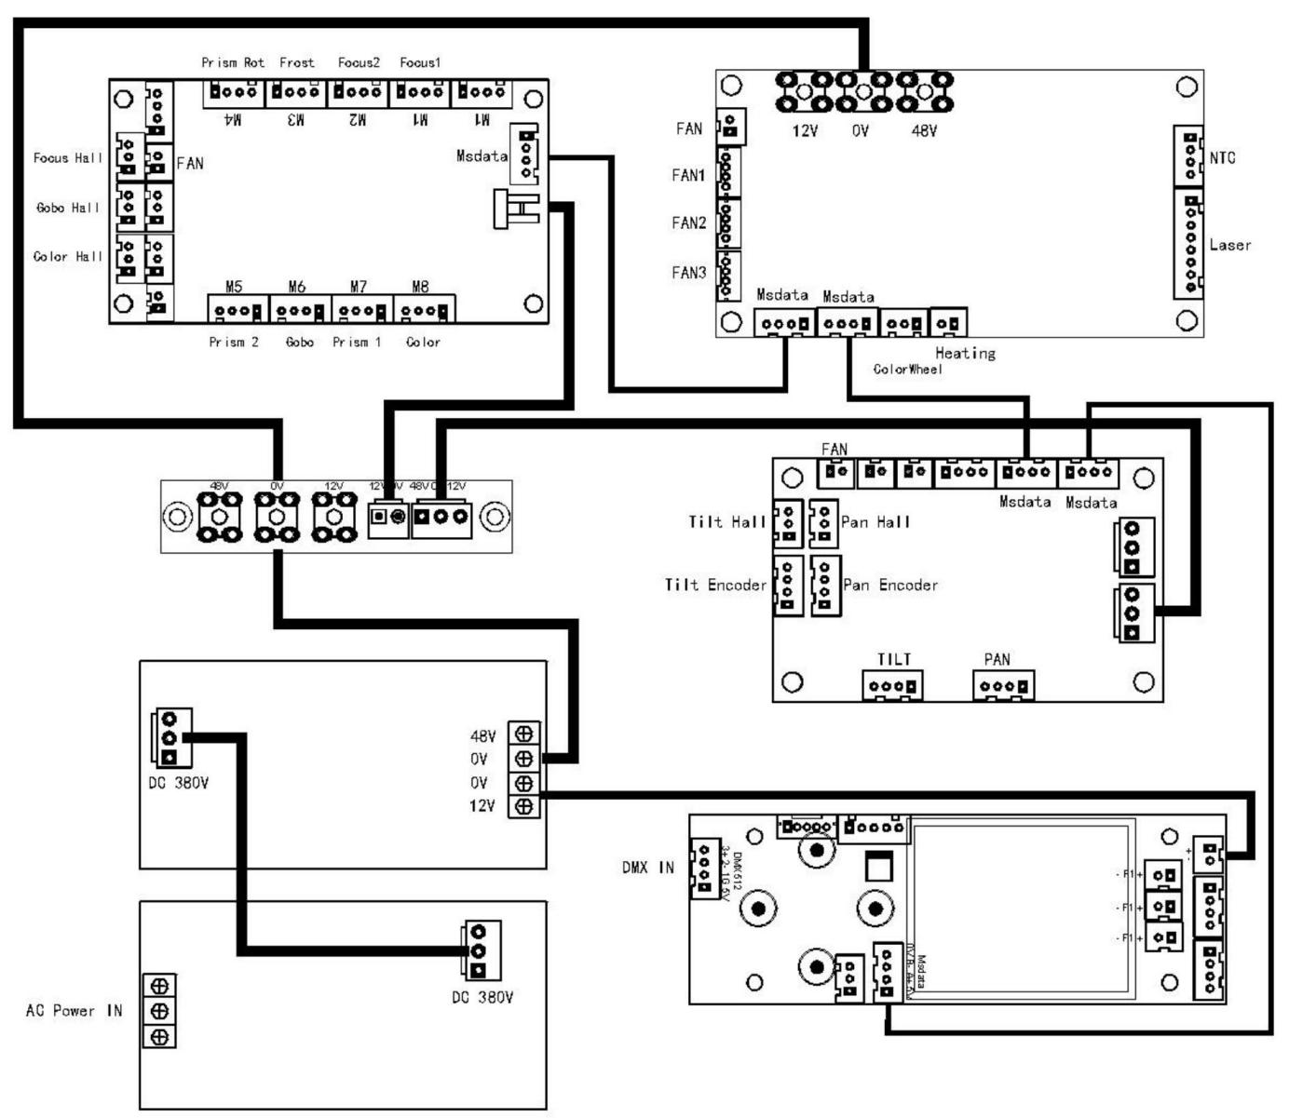

MAINTIAN
Lamps require daily cleaning. The time depends on the following factors related to the use environment and the cleaning cycle:
l Use a smoke machine, a fog machine
l High wind speed (e. g. inlet and outlet)
l Dust (e. g. stage effects, the structure of the building, and occasions required to simulate the natural outdoor environment)
l If one or more factors exist, check whether the lamp is cleaned after 100 hours of operation and check it periodically
All repairs not mentioned here shall be consulted by the technician.

WARN:
Disconnect the AC power supply before opening the lamp
housing and cool the lamp completely

l Be careful when cleaning the optical components, and work in a clean and bright place. Optical coated surfaces are fragile and easy to wipe flowers. Do not use solvents that can damage the plastic or colored surfaces.
l To maintain proper cooling, the fans and vents must be removed periodically
l Clean optical parts
l 1. Cut off the power supply and cool the lamp completely. Open the lamp enclosure.
l 2. Spray the air compressor.
l 3. Touch cotton paper with glass cleaner or pure water on cotton paper to wipe away stubborn stains. But can not wipe the surface, should gently repeat wipe.
l 4. Remove lampblack debris with alcohol cotton cloth. Glass cleaners can also be used, but use pure water to clean up the residue. Slowly clean from inside to outside.
l 5. Blow it dry with a clean and soft cloth or an air compressor.
l Clean the fan and air vents
l Use soft brushes, cotton cloth, vacuum cleaner or air compressor to remove dust from fans and vents.

