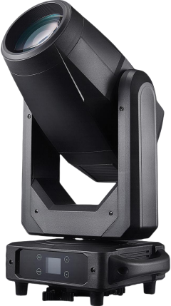
400LED BSW CMY WITH LINEAR CTO

GENERAL INFORMATION

INTRODUCTION
Please read and understand the instructions in this manual carefully and thoroughly before attempting
to operate this device. These instructions contain important safety and use information.
This product is intended for use by professionally trained personnel only, and is not suitable for
private use.
Unpacking
Every device has been thoroughly tested and has been shipped in perfect operating condition. Carefully
check the shipping carton for damage that may have occurred during shipping. If the carton is damaged,
carefully inspect the device for damage, and be sure all accessories necessary to install and operate
the device have arrived intact. In the event damage has been found or parts are missing, please contact
our customer support team for further instructions. Please do not return this device to your dealer
without first contacting customer support. Please do not discard the shipping carton in the trash. Please
recycle whenever possible.

IMPORTANT NOTICE!
THERE ARE NO USER SERVICEABLE PARTS INSIDE THIS UNIT.
DO NOT ATTEMPT ANY REPAIRS YOURSELF; DOING SO WILL VOID YOUR
MANUFACTURER'S
WARRANTY. DAMAGES RESULTING FROM MODIFICATIONS TO THIS FIXTURE AND/OR THE DISREGARD OF SAFETY INSTRUCTIONS AND GUIDELINES IN THIS MANUAL VOID THE
MANUFACTURER’S WARRANTY AND ARE NOT SUBJECT TO WARRANTY CLAIMS AND/OR REPAIRS.

SAFETY GUIDELINES
This device is a sophisticated piece of electronic equipment. To guarantee a smooth operation, it is important to follow all instructions and guidelines in this manual. ADJ PRODUCTS, LLC. is not responsible for injury and/or damages resulting from the misuse of this device due to the disregard of the information printed in this manual. Only the original included parts and/or accessories for this device should be used. Any modifications to the device, included and/or accessories will void the original manufactures warranty and increase the risk of damage and/or personal injury.

 | PROTECTION CLASS 1 - FIXTURE MUST BE PROPERLY GROUNDED  THERE ARE NO USER SERVICEABLE PARTS INSIDE THIS UNIT.
Δ | DONOTATTEMPTANYREPAIRSYOURSELF;DOINGSOWILLVOIDYOURMANUFACTURER’S WARRANTY. DAMAGES RESULTING FROM MODIFICATIONS TO THIS FIXTURE AND/OR THE DISREGARD OF SAFETY INSTRUCTIONS AND GUIDELINES IN THIS MANUAL VOID THE MANUFACTURE’S WARRANTY AND ARE NOT SUBJECT TO ANY WARRANTY CLAIMS AND/OR REPAIRS.  DO NOT PLUG FIXTURE INTO A DIMMER PACK!
Δ | NEVER OPEN THIS FIXTURE WHILE IN USE!  UNPLUG POWER BEFORE SERVICING FIXTURE!  NEVER TOUCH FIXTURE DURING OPERATION, AS IT MAY BE HOT! KEEP FLAMMABLE MATERIALS AWAY FROM FIXTURE!
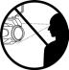 | NEVER LOOK DIRECTLY INTO THE LIGHT SOURCE!  RETINA INJURY RISK - MAY INDUCE BLINDNESS!  SENSITIVE PERSONS MAY SUFFER AN EPILEPTIC SHOCK!
 | INDOOR / DRY LOCATIONS USE ONLY!  DO NOT EXPOSE FIXTURE TO RAIN AND MOISTURE!  MINIMUM DISTANCE TO OBJECTS/SURFACES
Δ | MUST BE 39.4 FEET (12 METERS)  MAXIMUM TEMP OF EXTERNAL SURFACE 194°F (90°C)  MINIMUM DISTANCE OF INFLAMMABLE MATERIALS  FROM THE SURFACE 0.7 FEET (0.2 METER)


WARNING
---12.0 m

Minimum distance to lighted objects 12.0 meters.
Maximum temperature of the external surface is 90°C
Minimum distance of inflammable materials from the surface 0.2m.

SAFETY GUIDELINES

RISK GROUP 3 - RISK OF EXPOSURE TO ULTRAVIOLET UV RADIATION! THE FIXTURE EMITS A HIGH-INTENSITY WAVELENGTH OF ULTRAVIOLET UV LIGHT FROM THE UV COLOR FILTER. WEAR PROPER EYE AND SKIN PROTECTION. AVOID PROLONGED PERIODS OF EXPOSURE TO THE UV COLOR FILTER. AVOID WEARING WHITE CLOTHING AND/OR USING UV PAINTS ON THE SKIN. AVOID DIRECT EYE AND/OR SKIN EXPOSURE AT DISTANCES LESS THAN 11 FEET (3.3M). DO NOT OPERATE THE FIXTURE WITH DAMAGED/MISSING EXTERNAL COVERS. DO NOT LOOK DIRECTLY INTO THE UV LIGHT AND/ OR VIEW UV LIGHT DIRECTLY WITH OPTICAL INSTRUMENTS THAT MAY CONCENTRATE THE LIGHT/RADIATION OUTPUT. INDIVIDUALS SUFFERING FROM A RANGE OF EYE CONDITIONS, SUNLIGHT EXPOSURE DISORDERS, OR INDIVIDUALS USING PHOTOSENSITIVE MEDICATION MAY EXPERIENCE DISCOMFORT IF EXPOSED TO THE ULTRAVIOLET UV LIGHT EMITTED FROM THE UV LED.
DO NOT TOUCH the fixture housing during operation. Turn OFF the power and allow approximately 15-minutes for the fixture to cool down before servicing.
DO NOT shake the fixture; avoid brute force when installing and/or operating the fixture.
DO NOT operate the fixture if the power cord is frayed, crimped, damaged, and/or if any of the power cord connectors are damaged and do not insert into the fixture securely with ease.
NEVER force a power cord connector into the fixture. If the power cord or any of its connectors are damaged, replace it immediately with a new one of a similar power rating.
DO NOT block any air ventilation slots. All fan and air inlets must remain clean and never blocked. Allow approximately 7.9” (20cm) between the fixture and other devices or a wall for proper cooling.
When installing the fixture in a suspended environment, always use mounting hardware that is no less than M10 x 25 mm, and always install the fixture with an appropriately rated safety cable.
Always disconnect the fixture from the main power source before performing any type of service and/ or cleaning procedure.
Only handle the power cord by the plug end; never pull out the plug by tugging the wire portion of the cord.
During the initial operation of this fixture, light smoke or a smell may emit from the interior of the fixture. This is a normal process and is caused by excess paint in the interior of the casing burning off from the heat associated with the lamp and will decrease gradually over time.
Consistent operational breaks will ensure the fixture functions properly for many years.
ONLY Use the original packaging and materials to transport the fixture for service.

DISCHARGE LAMP WARNING

Q

Due to the high pressure involved in the construction of the lamp, it MAY EXPLODE DURING PROLONGED EXTENSIVE USE. This risk increases with age; added care is encouraged when dealing with older lamps. Thus, the lamp must always be replaced at the end of its recommended duty cycle. Extreme caution should be used when operating this or any fixture fitted with a gas discharge lamp.
UV RADIATION NOTICE

Δ

THIS FIXTURE EMITS INTENSE UV RADIATION, WHICH IS HARMFUL TO THE EYES AND SKIN. THE INTENSE LUMINESCENCE OF THE LAMP CAN CAUSE SEVERE DAMAGE TO THE RETINA. NEVER OPERATE THIS FIXTURE WITH ANY OF THE PROTECTIVE COVERS REMOVED. THESE COVERS HAVE BEEN SPECIALLY DESIGNED TO SHIELD AGAINST UV RADIATION.

This fixture is equipped with a DISCHARGE LAMP, which is highly susceptible to damage if mishandled. NEVER touch the lamp with your bare hands, as the oil from your hands will shorten the lamp’s life. NEVER move the fixture until the lamp has had ample time to cool. DISCHARGE LAMPS are NOT covered under warranty conditions. Avoid switching the fixture ON and OFF repeatedly in short intervals, as this will reduce lamp life and intensity. To achieve the intensity associated with discharge lamps, these lamps use gas sealed in a high-pressure environment to emit a brilliant output.
LAMP REPLACEMENT

Δ Δ
Δ

USE ONLY GENUINE ORIGINAL PHILIPS™ LAMPS. OTHER BRAND LAMPS WILL CAUSE DAMAGE AND VOID THE FIXTURE WARRANTY!
DISCONNECT THE MAIN POWER SUPPLY BEFORE REPLACING THE LAMP!
THE FIXTURE MUST COOL FOR 15 MINUTES BEFORE REPLACING THE LAMP! NEVER TOUCH THE LAMP WITH BARE HANDS; ALWAYS WEAR GLOVES!
OIL FROM HANDS WILL SHORTEN THE LIFE OF THE LAMP!

MAKE SURE ALL COVERS/FIXTURES ARE REPLACED/SECURED BEFORE OPERATING THE FIXTURE TO PREVENT ANY RISK AND/OR DAMAGE TO THE EYE RETINA FROM UV RADIATION EXPOSURE!

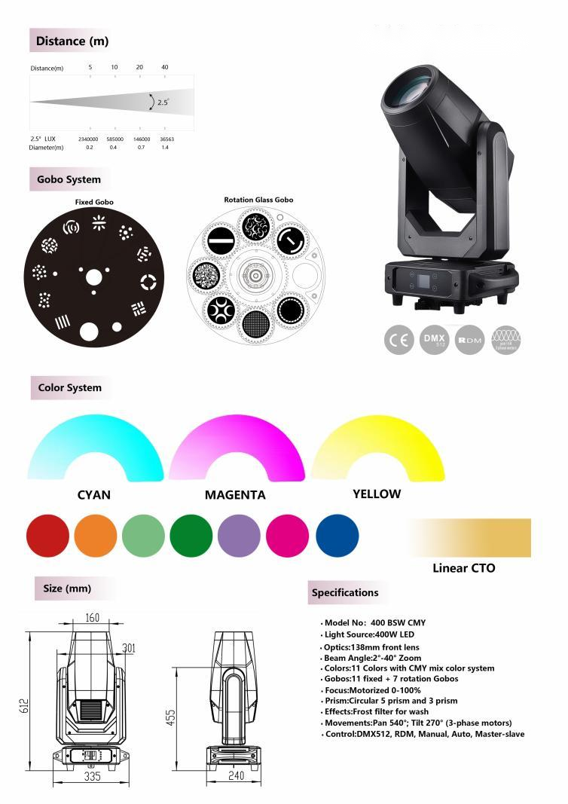

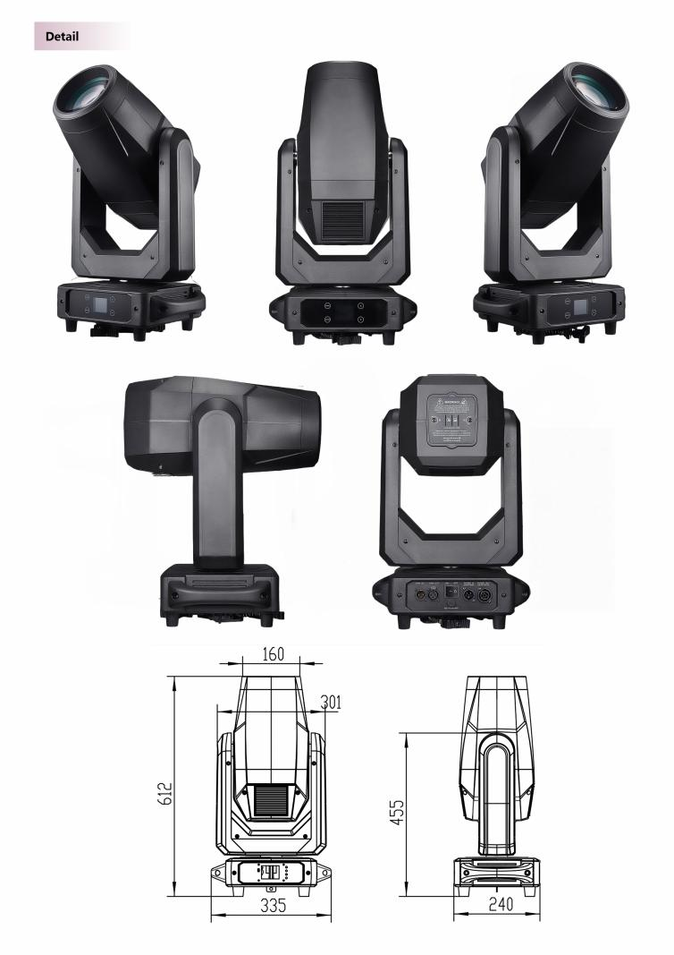

DMX TRAITS

CHANNEL | FUNCTION | DMX VALUE | EFFECT
25CH | FUNCTION | DMX VALUE | EFFECT
1 | Cyan | 000 - 255 | Cyan 0 -100%
2 | Magenta | 000 - 255 | Magenta 0 - 100%
3 | Yellow | 000 - 255 | Yellow 0 - 100%
4 | CTO | 000 - 255 | CTO 0 - 100%
5 | Colour wheel | 000 - 005 | White color
5 | Colour wheel | 006 011 | White + color 1
5 | Colour wheel | 012 017 | Color 1
5 | Colour wheel | 018 - 023 | Color 1 + color 2
5 | Colour wheel | 024 029 | Color 2
5 | Colour wheel | 030 035 | Color 2 + color 3
5 | Colour wheel | 036 - 041 | Color 3
5 | Colour wheel | 042 047 | Color 3 + color 4
5 | Colour wheel | 048 053 | Color 4
5 | Colour wheel | 054 - 059 | Color 4 + Color 5
5 | Colour wheel | 060 065 | Color 5
5 | Colour wheel | 066 071 | Color 5 + color 6
5 | Colour wheel | 072 - 077 | Color 6
5 | Colour wheel | 078 083 | Color 6 + color 7
5 | Colour wheel | 084 089 | Color 7
5 | Colour wheel | 090 095 | Color 7+CTO
5 | Colour wheel | 096 174 | Clockwise rotation fast to slow
5 | Colour wheel | 175 176 | Stop
5 | Colour wheel | 177 255 | Counter clockwise rotation slow to fast
6 | Strobe | 000 009 | Open
6 | Strobe | 010 199 | Pulse Effect slow to fast
6 | Strobe | 200 249 | Random Strobe
6 | Strobe | 250 255 | open
7 | Dimmer | 000 - 255 | Dimmer 0 - 100%
8 | DimmerFine | 000 - 255 | Dimmer Fine 0 - 100%
9 | Static Gobo | 000 - 003 | Open
9 | Static Gobo | 004 - 007 | Gobo1
9 | Static Gobo | 008 - 011 | Gobo2
9 | Static Gobo | 012 - 015 | Gobo3
9 | Static Gobo | 016 - 019 | Gobo4
9 | Static Gobo | 020 - 023 | Gobo5
9 | Static Gobo | 024 - 027 | Gobo6
9 | Static Gobo | 028 - 031 | Gobo7
9 | Static Gobo | 032 - 035 | Gobo8
9 | Static Gobo | 036 - 039 | Gobo9
9 | Static Gobo | 040 - 043 | Gobo10
9 | Static Gobo | 044 - 047 | Gobo11
9 | Static Gobo | 048 - 117 | Clockwise rotation fast to slow
9 | Static Gobo | 118 - 119 | Stop
9 | Static Gobo | 120 - 189 | Counter clockwise rotation slow to fast
9 | Static Gobo | 190 - 195 | Gobo1 Shaking Slow to Fast
9 | Static Gobo | 196 - 201 | Gobo2 Shaking Slow to Fast
9 | Static Gobo | 202 - 207 | Gobo3 Shaking Slow to Fast
9 | Static Gobo | 208 - 213 | Gobo4 Shaking Slow to Fast
9 | Static Gobo | 214 - 219 | Gobo5 Shaking Slow to Fast
9 | Static Gobo | 220 - 225 | Gobo6 Shaking Slow to Fast
9 | Static Gobo | 226 - 231 | Gobo7 Shaking Slow to Fast
9 | Static Gobo | 232 - 237 | Gobo8 Shaking Slow to Fast
9 | Static Gobo | 238 - 243 | Gobo9 Shaking Slow to Fast
9 | Static Gobo | 244 - 249 | Gobo10 Shaking Slow to Fast
9 | Static Gobo | 250 - 255 | Gobo11 Shaking Slow to Fast

10  11 | Rotation Gobo  Rotating Gobo Wheel | 000 - 007 | Open
10  11 | Rotation Gobo  Rotating Gobo Wheel | 008 - 015 | Gobo1
10  11 | Rotation Gobo  Rotating Gobo Wheel | 016 - 023 | Gobo2
10  11 | Rotation Gobo  Rotating Gobo Wheel | 024 - 031 | Gobo3
10  11 | Rotation Gobo  Rotating Gobo Wheel | 032 - 039 | Gobo4
10  11 | Rotation Gobo  Rotating Gobo Wheel | 040 - 047 | Gobo5
10  11 | Rotation Gobo  Rotating Gobo Wheel | 048 - 055 | Gobo6
10  11 | Rotation Gobo  Rotating Gobo Wheel | 056 - 071 | Gobo7
10  11 | Rotation Gobo  Rotating Gobo Wheel | 072 - 113 | Continuous CCW rotation linear fast to slow
10  11 | Rotation Gobo  Rotating Gobo Wheel | 114 - 117 | Stop rotation
10  11 | Rotation Gobo  Rotating Gobo Wheel | 118 - 159 | Continuous CW rotationlinear slow to fast
10  11 | Rotation Gobo  Rotating Gobo Wheel | 160 - 171 | Gobo1 Shaking Slow to Fast
10  11 | Rotation Gobo  Rotating Gobo Wheel | 172 - 183 | Gobo2 Shaking Slow to Fast
10  11 | Rotation Gobo  Rotating Gobo Wheel | 184 - 195 | Gobo3 Shaking Slow to Fast
10  11 | Rotation Gobo  Rotating Gobo Wheel | 196 - 207 | Gobo4 Shaking Slow to Fast
10  11 | Rotation Gobo  Rotating Gobo Wheel | 208 - 219 | Gobo5 Shaking Slow to Fast
10  11 | Rotation Gobo  Rotating Gobo Wheel | 220 - 231 | Gobo6 Shaking Slow to Fast
10  11 | Rotation Gobo  Rotating Gobo Wheel | 232 - 255  000 127 | Gobo7 Shaking Slow to Fast  Gobo wheel position
10  11 | Rotation Gobo  Rotating Gobo Wheel | 128 190 | Continuous CCW rotation linear fast to slow
10  11 | Rotation Gobo  Rotating Gobo Wheel | 191 192 | Stop rotation
10  11 | Rotation Gobo  Rotating Gobo Wheel | 193 - 255 | Continuous CW rotationlinear slow to fast
12 | GoboRot Fine | 000 - 255 | Rotating Gobo Wheel Fine
13 | Prism 1 | 000 127 | Prism out
13 | Prism 1 | 128 255 | Prism in
14 | Prism1 Rotation | 000 127 | Prism position
14 | Prism1 Rotation | 128 190 | Counter-Clockwise Rotation fast to slow
14 | Prism1 Rotation | 191 192 | stop
14 | Prism1 Rotation | 193 - 255 | Clockwise Rotation slow to fast
15 | Prism2 | 000 127 | Prism out
15 | Prism2 | 128 255 | Prism in
16 | Prism2 Rotation | 000 127 | Prism position
16 | Prism2 Rotation | 128 190 | Counter-Clockwise Rotation fast to slow
16 | Prism2 Rotation | 191 192 | stop
16 | Prism2 Rotation | 193 - 255 | Clockwise Rotation slow to fast
17 | Frost | 000 255 | Frost Linear
18 | Zoom | 000 - 255 | Zoom 0-100%
19 | Focus | 000 - 255 | Focus 0-100%
20 | Focus Fine | 000 - 255 | Focus Fine 0-100%
21 | Pan | 000 - 255 | Pan 0-100%
22 | PanFine | 000 - 255 | Pan fine 0-100%
23 | Tilt | 000 - 255 | Tilt 0-100%
24 | Tilt Fine | 000 - 255 | Tilt Fine 0-100%
25 | Reset | 026 076 | Head reset
25 | Reset | 077 - 127 | Pan and tilt reset
25 | Reset | 128 - 255 | Whole light reset

